**Scenario: User bypasses SSL warning**

**Step: Launch "expired_page" WebPage - PASS**

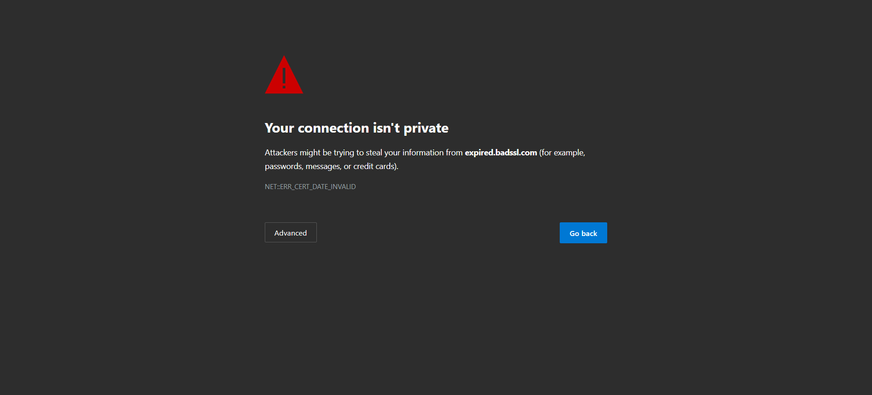

**Step: When the user clicks the Advanced option and clicks Proceed - PASS**



**Step: And the user validate the page title with"expired.badssl.co" - FAIL**



**Execution Summary:  
Total Steps: 3  
Passed: 2  
Failed: 1**